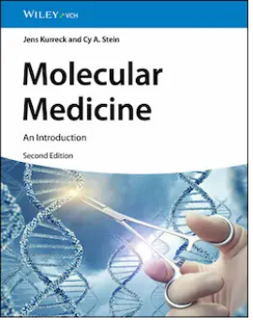
Molecular Medicine: An Introduction,
2nd Edition
Jens Kurreck, Cy Aaron Stein
ISBN: 978-3-527-35239-5
April 2025
464 pages
NOK 1299,-

